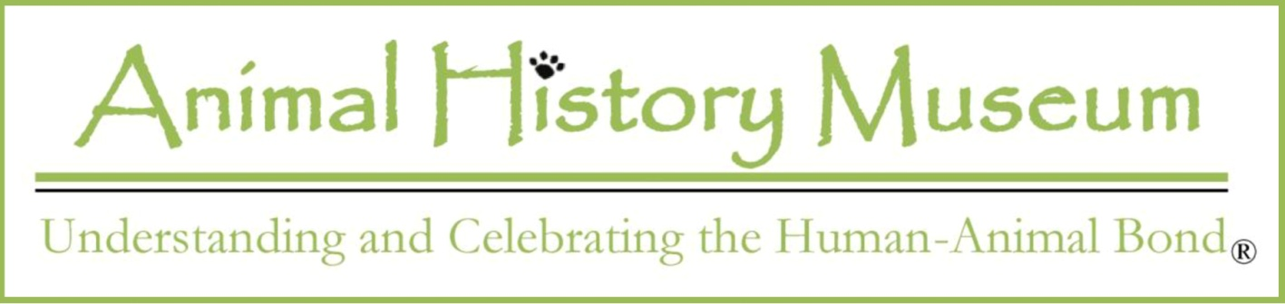

Press Card Application
This application must be completed by each organization and list each individual for whom a press pass is sought. PLEASE PRINT OR TYPE CLEARLY AND PDF BACK TO info@animalhistorymuseum.org:

Organization __________________________ Contact _________________________

Address _______________________________________________________________

Phone/Fax ____________________________________________________________

Website _______________________________________________________________

FB, Twitter, IG, etc. ______________________________________________________

Individual #1:

Last Name____________________________ First____________________ MI _____

Phone __________________________ Email ________________________________

STATE-ISSUED ID (MUST BRING WITH YOU TO EVENT):

Type _____________________ State of Issue ____ ID # ______________________

Individual #2:

Last Name____________________________ First____________________ MI _____

Phone __________________________ Email ________________________________

STATE-ISSUED ID (MUST BRING WITH YOU TO EVENT):

Type _____________________ State of Issue ____ ID # ______________________

~Please attach a separate sheet for more individuals if necessary ~
Eligibility Statement
To be eligible to receive a Press Card, an individual must be a member of the press who covers, in person, fashion-related, animal-related and/or museum-related events ("qualifying events"). Where a cursory internet or similar search does not establish the requesting organization or individual(s), the Animal History Museum reserves the right to require samples of articles, commentaries, books, photographs, videos, films or audios published or broadcast within the six months immediately preceding this application, sufficient to show that the applicant covered in person two (2) or more Covered Events occurring on separate days.

Responsibility for Minors
Where an eligible organization seeks a Press Card(s) for one or more minors, the organization understands and agrees that it will be responsible for all aspects of its minors' care at all times. This includes, but is not limited to, providing adequate supervision for its minors at all times during the event. The organization further agrees to indemnify and hold harmless the Animal History Museum for any and all injury and/or loss to the organization's minors arising from minors' coverage of event.

I HAVE READ THE ELIGIBILITY STATEMENT AND HEREBY DECLARE THAT THE ABOVE FACTS ARE TRUE TO THE BEST OF MY KNOWLEDGE:

_________________________________________ ____________________
Signature (on behalf of requesting organization or Date
individual if no organization)

For questions about pres passes, including confirmations, please email us at info@animalhistorymuseum.org. Thank you.

Animal History Museum
121 W. Lexington Dr., Suite 202 | ofc
Glendale, California 91203

www.animalhistorymuseum.org
fb & ig | animalhistorymuseum
twitter | @animal_history
pinterest | animalhistory/boards

530 S. Lake Ave., #444 | P.O.
Pasadena, California 91101

A 501(c)(3) organization
Tax I.D. 45-2530183

